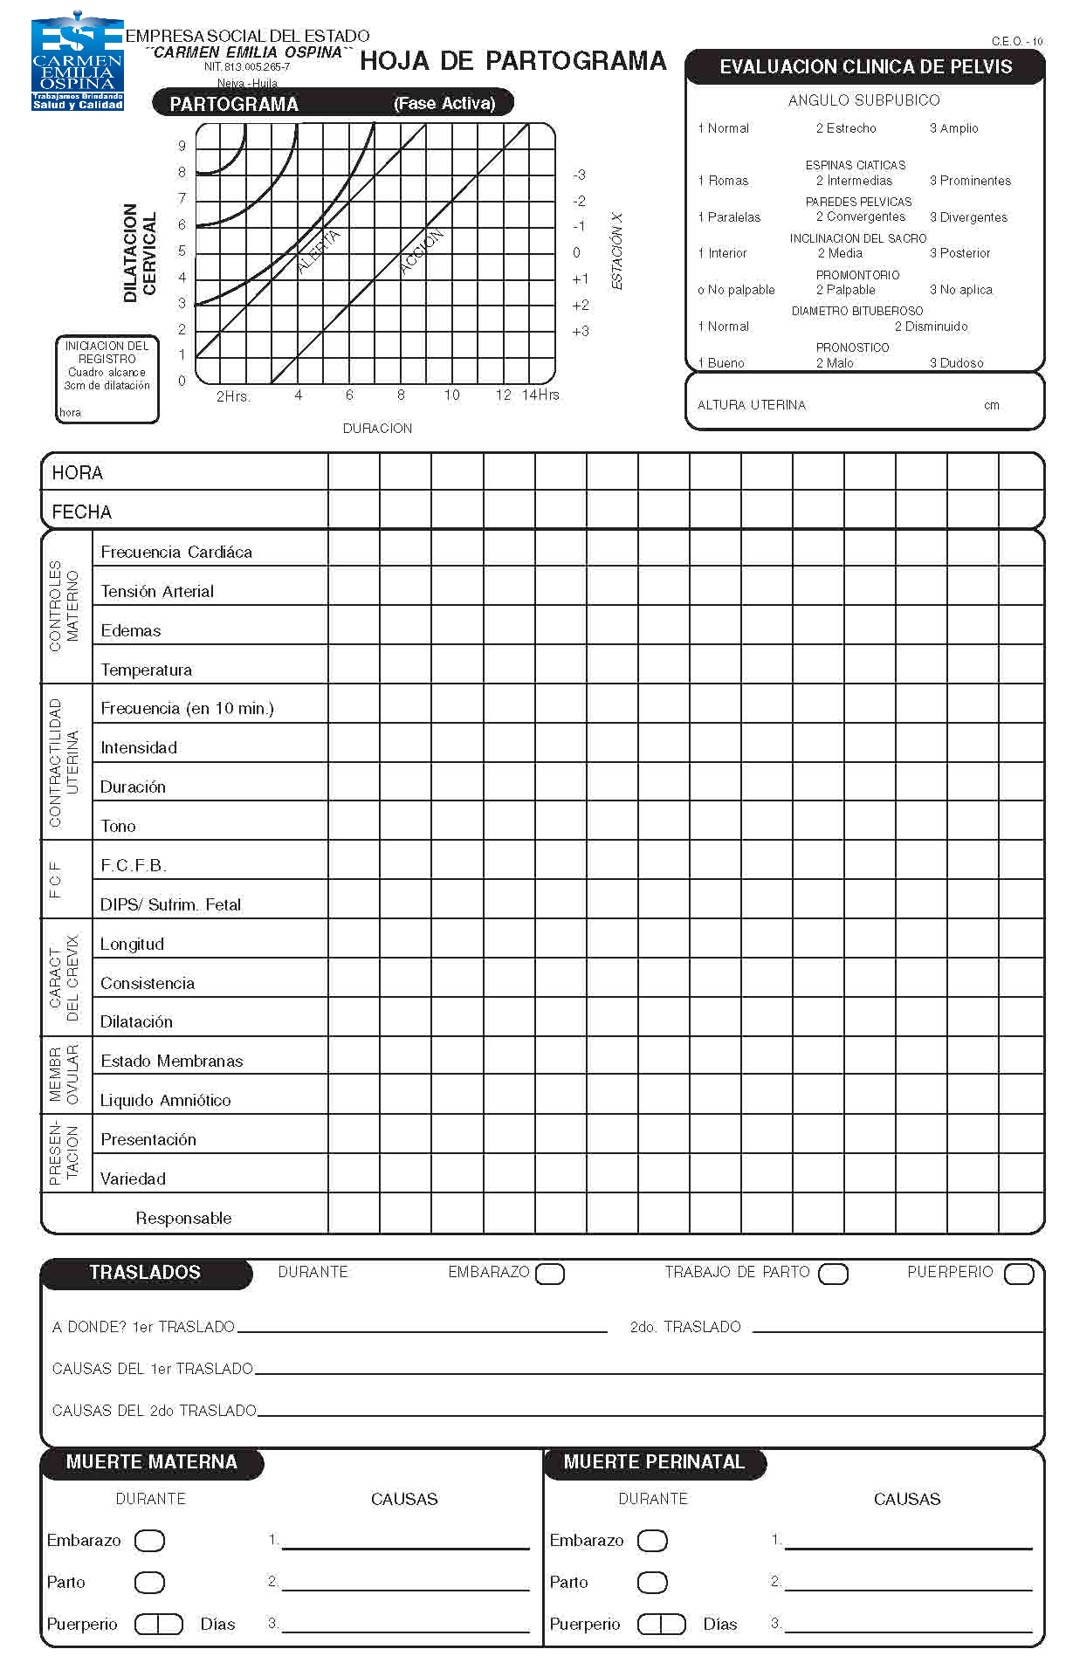
SH-S2F5V2-25/11/2013

